Ideation Phase
Define the Problem Statements

Date | 15-02-2026
Team ID | LTVIP2026TMIDS81358
Project Name | OrderOnTheGo : Your On-Demand Food Ordering Solution
Maximum Marks | 2 Marks

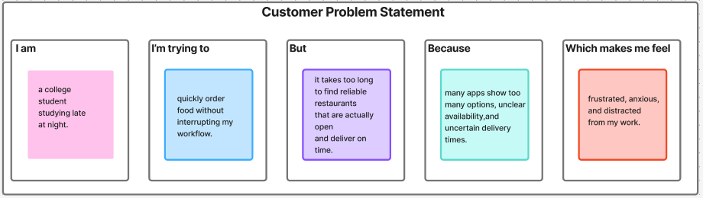

Problem Statement (PS) | I am (Customer) | I’m trying to | But | Because | Which makes me feel
PS-1 | a hungry user ordering food during unconventional hours. | make a confident decision about what to eat. | I cannot fully trust the reviews, pricing clarity, and final delivery cost shown upfront. | hidden charges and inconsistent experiences have reduced my trust in food delivery platforms. | uncertain and hesitant before placing my order.
PS-2 | a time-sensitive user with low energy late at night. | complete my order in the fastest and simplest way possible. | the checkout process feels lengthy and requires multiple steps and repeated information. | the platform does not minimize effort or support quick decision-making. | mentally drained and impatient.

